Drogues
This part of the Pacific is a place where the use of a drogue is very useful. Sometimes for use in bad weather, and sometimes, just for a rest in nasty weather. Chameleon uses a Jordan Series drogue. It is self-contained in a box fixed to the aft deck and ready to deploy when needed. Beside the box that contains the drogue we have a wheel of chain and rope which can be used for the drogue or a stern anchor if needed. We reinforced the aft cleats , with steel plates, which most boats need to do if you are going to use a drogue.

The following comes from the catamaran Panache.
As we prepare for our passage to New Zealand, we are reviewing our safety gear. The photo shows our Drogue setup. A Drogue is a small but tough underwater “parachute” that you tow behind the boat to slow you down and keep you steady in high winds/seas. We have never used it and don’t anticipate needing it for this passage, but it’s best to be prepared. The Towing Bridle has two arms that attach to a cleat on either side of Panache’s stern. It forms a “V” behind the boat to which a long and strong Dyneema Line attaches it to the Drogue. The Chains attach to the back of the Drogue to hold it underwater. All the components are stored together for easy deployment. It’s one of those things that you purchase but hope you never need to use.
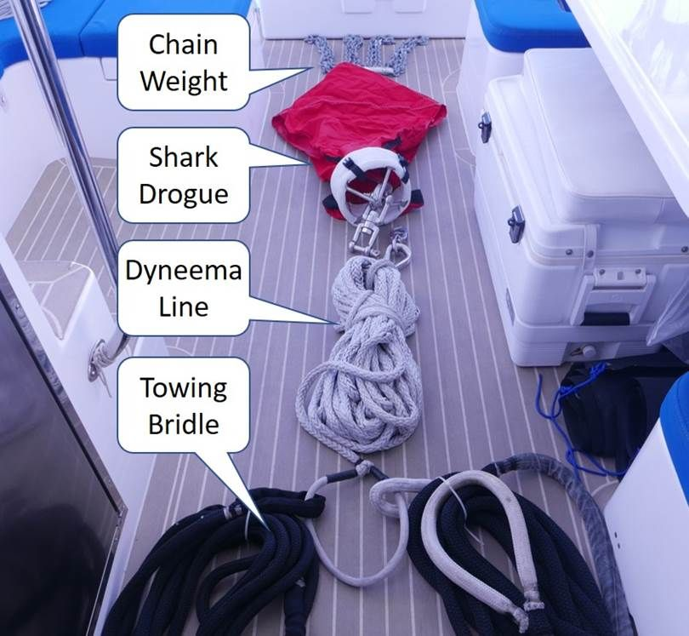

A schematic of the set up is:
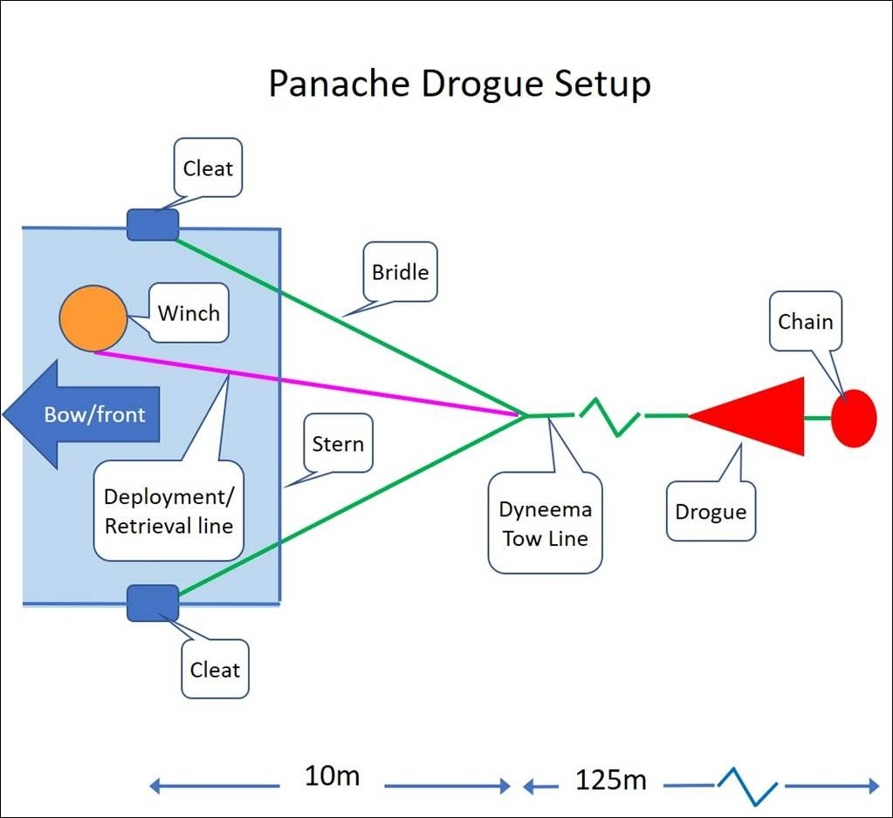

Thanks for this Price. Interesting to see that drogues are useful for catamarans too.
November 2019.

Make your own Series Drogue
The following contribution is from Hilton Ward and his wife Melva who made their own series drogue and have kindly shared the instructions. They cruised in their 9.6m sailboat Spindrift in the SW Pacific and up to Alaska. These instructions are published by SailRite. It is an 11 page document and includes comments from Don Jordan.

