500hPa Anaysis : An important weather aid for Cruisers
David Sapiane Gulf Harbour Radio 2017-08-22

Listeners to Gulf Harbour radio will know that I always start the weather update with a discussion of the upper levels. An understanding of this is really important if you want to work out what is happening with the weather .

You do of course need the internet and there are various places to find 500mb information. The easiest is to Google “weatheronline expert charts”.
Open the page and then on the left column chose Pacific (SE).
Then further down on the left chose Height/Temp 500hPa . It is under Upper Level.
On the right chose GFS and a time period. Here is what we downloaded today, for 12hr.

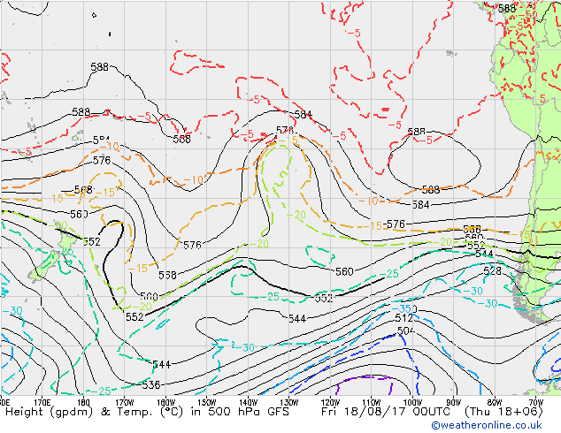

Wow, let’s take a break for some explanation.
Take a piece of paper. Hold it – left hand one end and right hand the other end.
Hold it out in front of you edge on. The edge is 500mb. It represents a pressure level.
Now with arms outstretched bring your hands a bit closer together so that the centre of the paper bows to the floor.
Now pretend that your left and right hands represent 5,600m above ground.
A line drawn from front to back along the lower part of the U shape represents the axis of the U.
Picture the U as a valley with a road connecting the left side and the right side. You are in a car travelling from the left to the right. On the left you are going downhill and on the right you go up hill.
So, using your imagination trade the car for air flow. On the left side of the valley’s axis air flows down to the surface – building a high pressure area.
On the right side of the axis air goes up, creating a low pressure area.
With this exercise you can see how highs and lows form. This exercise is extremely elementary but from a yachtie standpoint it is probably sufficient.
With this in mind you are ready for the next development.

Instead of choosing Height/Temp 500mb, on that left column chose V-AdV 500hPa and you will get two charts. The first is the 500mb you got before. The second chart gives rain and the surface analysis for the same time period and you can go from one to the other to see how the upper level affects the surface. Have a play around with various time periods to follow a feature like a depression.

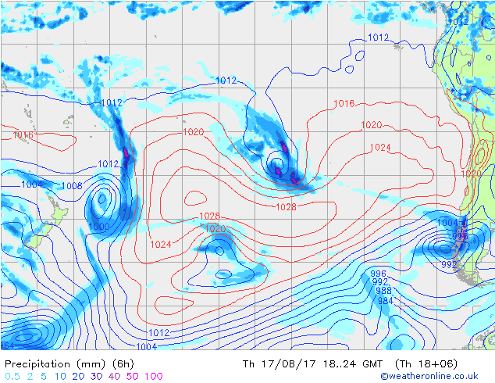

There are reams of data on 500mb (hPa) charts. There are many internet sites that offer different parameters at that level. Examples of this are speed, moisture content, temperature, dewpoint. There are also text books that delve deeply into this most informative atmospheric level. However most of the information is very technical and tends to turn off the average yachtie who doesn’t need that degree of understanding. The following is my choice of Fourteen Points that may prove useful when viewing a 500mb chart.

1. Recognise that areas east of the axis of a 500mb trough can spawn depressions, accentuate existing surface troughs or fronts, or bring inclement weather even in the absence of data to the contrary on synoptic charts.
2. Areas west of a 500mb trough or east of a 500mb ridge will generally have fine and dry weather.
3. When a 500mb trough moves directly over a surface Low the surface Low may start to fill.
4. The 5640 meter contour represents the approximate track a Depression will follow. Not under the contour, but the same direction the contour is pointing.
5. If at the 500mb level there are more than one closed contour line the surface low underneath will be slow moving and move with the direction of the closed contour.
6. If the 500mb contours are approximately straight lines west to east, and the winds stronger to the west, the flow may transition to 500mb troughs and ridges.
7. If winds are strongest on the west side of a 500mb trough axis the trough will ‘dig’ toward the equator and strengthen.
8. If winds are uniform around the 500mb trough the trough will probably remain over the surface low, and this low will deepen.
9. If the winds to the east of the 500mb trough axis are stronger than the west side, then the trough will open up or flatten and the surface low may fill or run to higher latitudes (a polar track)
10. The axis of troughs usually show rotation which is simply due to the short wave riding around a long wave.
11. Positive tilt means the trough axis leans to the west and that tilt encourages a surface low to deepen.
12. Negative tilt means the trough axis leans to the east and usually causes the surface low to wind down and fill, BUT
13. If the upper winds are stronger west of the negative tilt axis than on the east side, the surface low or surface trough will develop with more intensity. These lows then become quite severe.
14. Looking at the 500mb chart even a gentle upper 500mb trough that makes it to the tropics (contour lines reach north of 23S) should be a real worry as it may generate a surface low with winds exceeding 30 kts. This was the scenario in the ill fated Queens Birthday Storm of 1 June 1994 that claimed yachts and lives. Surface charts started to pick up changes on 2 June and finally one weak surface isobar on 3 June. However the 500mb charts picked up an upper trough 31 May.

This endeavour is far from complete. Other events cause more surface changes. In the upper levels we could examine Cut Off Lows, Blocking Patterns and more. It may help to realise that 500mb heights are higher in warm air masses and lower in cold air masses, thus the heights are lower nearer the poles than the equator. And remember the tighter the contours the greater the wind speeds. Also be aware that more than one short wave can be in close proximity to another. If they become aligned, meaning the axis of one is directly above the axis of the second as you view the chart, this is bad news as surface lows are hugely enhanced.

Those of you with further interest can explore the internet for a new world of education. The purpose of this exercise is to help the average yachtie understand 500mb charts and use that information to double check what gribs are saying and what synoptic charts are proposing - all to allow you to become more informative and safe at sea.

Need some help with the original 500hPa chart? Here is the first chart with the features identified.

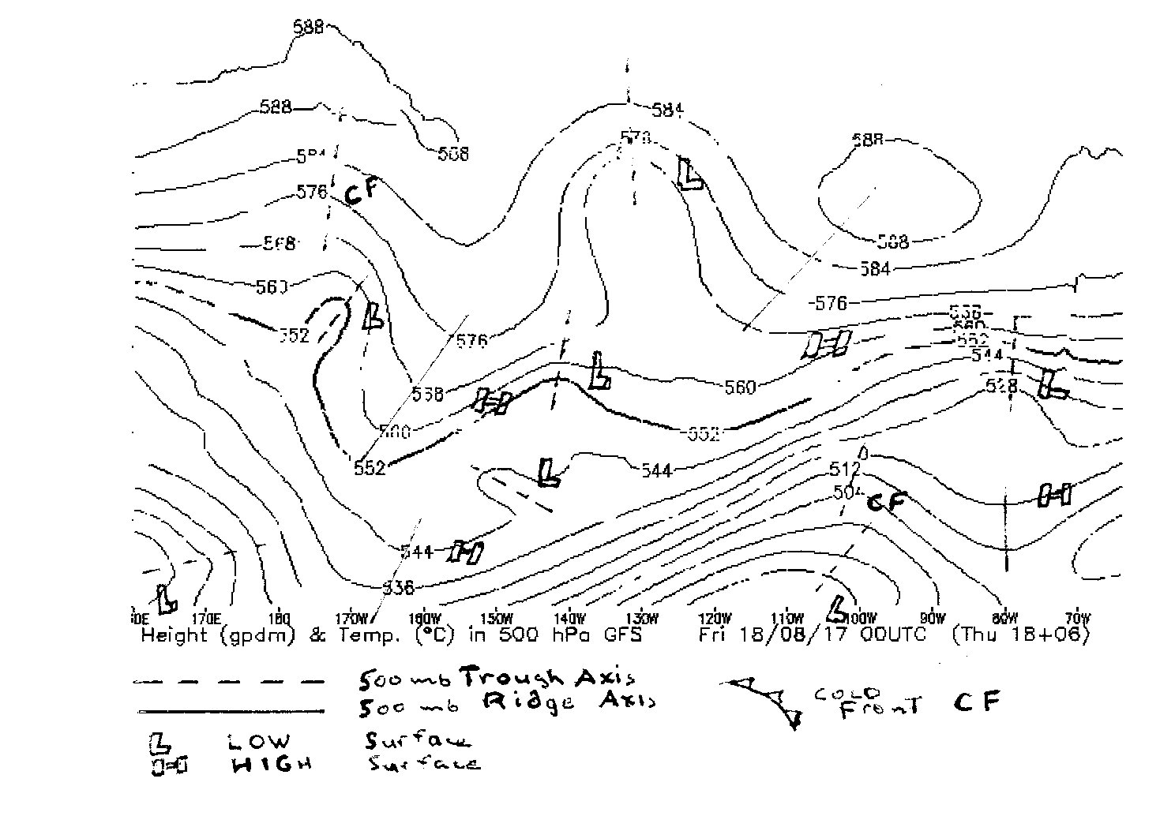

October 2019
Those of you who have ‘seen the light’ and want to look at the upper levels, then try the following as it is better than the site discussed above.
https://mag.ncep.noaa.gov/model-guidance-model-parameter.php?group=Model%20Guidance&model=GFS&area=SOUTH-PAC&ps=area#

Yes, it is a long address but it was easier to take you directly to this spot. Now, you can choose from many choices. For 500mb click on 500vor ht. Wait a minute and a chart of forecast hours will appear. (Upper air – on the rIght hand side.) Pick any day you wish, or if you want a loop, which I advise, click on 3 day or 5 day or whatever. This Site offers many other charts, so explore and learn. Dave.

